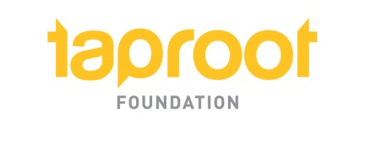

COMMON APPLICATION template

This template has been developed by the Taproot Foundation as a suggestion of best practices for nonprofits when they are soliciting pro bono services from potential partners. Although a final requested scope of work should be drafted in collaboration with the potential pro bono provider, making an initial ask will go farther if it contains some specific key elements which this template has been designed to help you capture and share:

- Elevator pitch on your organization and its impact

- Your needs and a quick explanation of how you determined them and how they relate to your mission

- The impact their help can have

- The skills and experience you believe are required

- A clear sense of your timing and an estimate for the duration of time and/or total hours necessary

- Your recommendation for the most effective model of pro bono service to meet your current need, if relevant

- How you are prepared to be a good pro bono client

- A short explanation of any additional resources that may be required to complete the project

request for pro bono services

Who is this request for?
Organization Name
Street Address
Phone
Website (if applicable)
Tax ID
Employee Name
Title
Phone
Email

Who are you making the ask of?
Company Name
Affiliation (if applicable)
Street Address
Phone
Email

What do you do and how do you do it?
Mission and Vision
Program Overview

About the requested pro bono services
What need are you trying to address?
What is your idea for a project and what does the final deliverable look like?
How do you believe this project help your organization and how is it related to your strategic priorities? What measures will indicate if it is a success?
What skill-sets/experience do you believe are required?
What model of service delivery do you believe will be best?
When should this project happen? (Be as specific as possible)
How long do you think this project will take? (Duration and/or hours if possible)

About your organization’s readiness as a pro bono client
Who in your organization will manage the engagement? Why are they appropriate?
What resources will your organization dedicate to this project?
How will you implement and sustain the project deliverable/results?

